Management Engineering Surgery Projects Report

Case Study, Valley Presbyterian Hospital

March 10, 2009

David Belson, Ph.D.

University of Southern California

Work funded by a grant from the California HealthCare Foundation, 08-1170, to stimulate the use of management engineering in surgery in California Safety Net Hospitals.

Table of Contents

I. Summary 2
II. Background 2
A. Project Selection 2
B. Methodology 3
C. The Issues 4
III. Conclusions 6
IV. Valley Presbyterian Hospital 8
A. Hospital Background 8
B. Findings 12
C. Recommendations 13
D. Data & Results 14
V. Appendix 20
A. Proposal Evaluation Matrix 20
B. Project Startup Checklist 20
C. Hospital Data 21

Summary

Inefficiencies in the delivery of care limit the capacity of health care providers to serve patients, impeding access to care. The goal of this project was to achieve significant improvements in surgery at California safety net and critical access hospitals though development and adoption of best practices for management engineering.

Our team of faculty and staff from the USC Viterbi School of Engineering began three patient flow improvement projects at three California safety net hospitals in October 2008. These hospitals were selected based on proposals submitted to the California Healthcare Foundation, the project sponsor. Each hospital expressed a desire to increase throughput and eliminate bottlenecks. The three hospitals qualified as safety net hospitals but they differed in size, residency programs and ownership.

They all followed a similar patient flow pattern in surgery, beginning with registration and ending with recovery. The management engineering team sought to improve overall throughput by increasing the efficiency at each step, eliminating waste, reducing bottlenecks and better coordinating the movement of patients between steps.

The projects began with senior management meetings at each hospital and group meetings with nearly all of the surgery staff. Data were collected regarding patient flow. We analyzed the surgery data for recent months including times of patient movement, types of surgery, advance schedules and mix of patient types. The hospitals provided us with digital records of daily surgeries. These revealed delays and under utilized resources. The engineering team observed the daily surgery flow and interviewed many of the surgeons, anesthesiologists and nurses. This direct surgery observations and later flowcharting and analysis proved to be particularly helpful in developing ideas for change.

This report draft includes only the material of Valley Presbyterian Hospital (Section IV) and not the other two hospitals that were studied.

Background

These projects follow three projects done earlier in radiology and surgery departments at other California safety net hospitals. The results of the radiology work are described in a California HealthCare Foundation Issue brief. (Available at http://www.chcf.org/topics/view.cfm?itemID=133532 ) The goal was to achieve significant improvements in care delivery at California safety net and critical access hospitals and demonstrate the usefulness of management engineering. By so doing, hospitals would be encouraged to implement their own ongoing management engineering function and process improvements.

Project Selection

A team of faculty and staff from the USC Viterbi School of Engineering began patient flow improvement projects at three California safety net hospitals (Valley Presbyterian Hospital, St. Francis Hospital and San Francisco General Hospital) in September 2008. These hospitals were selected based on proposals responding to a request for proposals (RFP) issued in July 2008 by the California Healthcare Foundation, the project sponsor. The hospitals were evaluated on a weighted multi attribute basis. See Appendix A.

Each selected hospital expressed a desire to increase throughput and eliminate bottlenecks within surgical departments, and to work with the USC team to implement change. Though all three hospitals qualified as safety net hospitals, they differed in size, residency programs and ownership (Table 1).

In order to receive the grant based management engineering service the hospitals had to agree to certain policies, such as making available relevant operating data for use in this report. Each project began with a checklist verifying the terms of the agreement and initial steps. (See Appendix B)

The three hospitals followed a similar patient flow pattern in surgery, as shown in Figure 1, beginning with admission and ending with recovery.

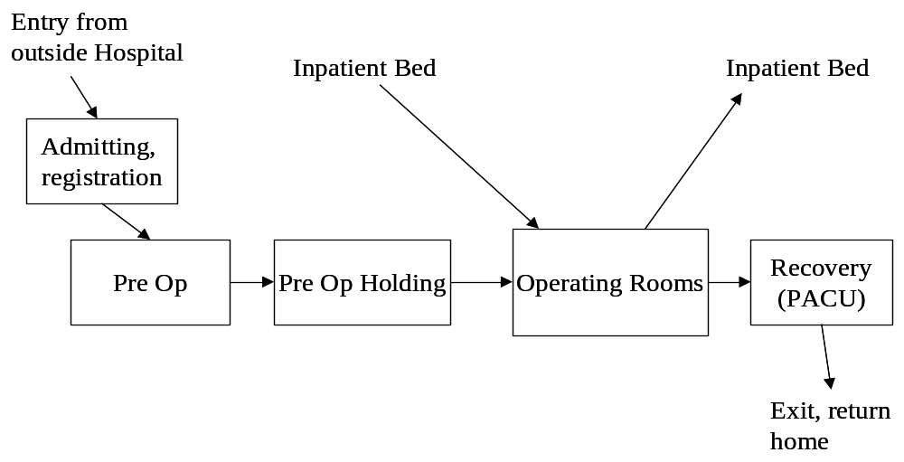
Figure 1. Typical Overall Surgery Patient Flow

Methodology

Our methodology requires close collaboration with all levels of staff, combined with careful observation and analysis of system performance. The projects began with senior management meetings at each hospital and group meetings with nearly all of the surgery staff. anesthesiologists.

Each project involved a series of necessary tasks. The challenges within each step were remarkably similar among the three hospitals. The management engineering team conducted the initial individual steps but the hospital’s staff increasingly led the later stages. (See Figure 2.)

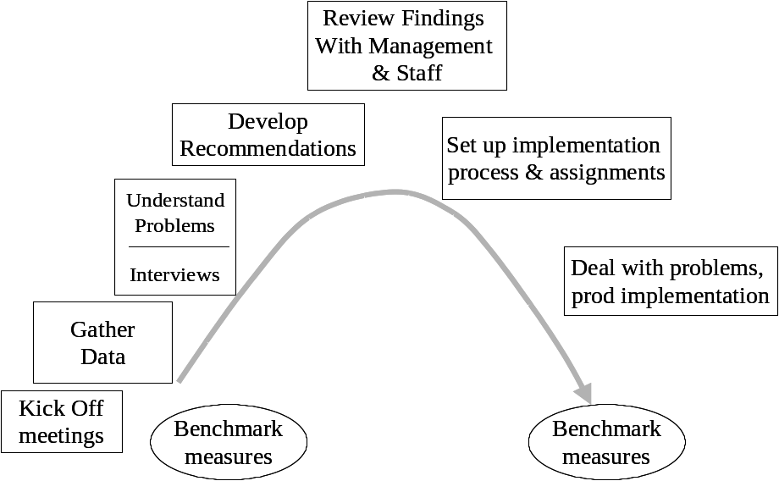

Figure 2. Sequence of tasks for the management engineering projects
Measurement: An important resource in management engineering is to have an accurate measure of the patient flow. We primarily focused on room turnaround time (TOT), at the request of the hospital, but also recognized other metrics as important such as room utilization, schedule accuracy and delays.

The Issues

Efficient utilization of surgery resources involves timely execution of a series of steps. Delays constitute waste, which results in idle time for patients, staff and facilities. More importantly, it reduces the capacity of the hospital – fewer patients can be seen and there is a longer wait for a surgery appointment with adverse clinical effects.

The basic sequence of time related to operating room turnover for all patient types is shown below.

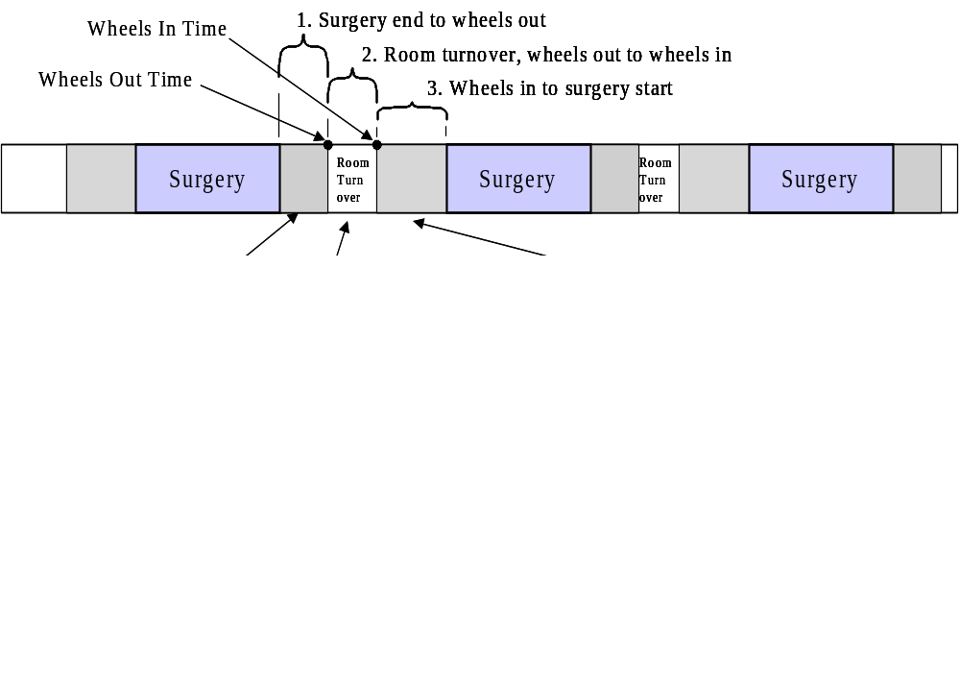
Figure 4 Room Turnover Steps

Each of these steps depends on a number of events; much of the effort in this project has been directed at reducing bottlenecks that prevent these events from occurring when needed.

Improving patient flow can be measured a number of ways. We found the following measures of effectiveness. These metrics could be incorporated into a surgery “report card” that would be useful to manage the area.

Useful metrics, and typical ways to measure them:

- Turnover time (TOT) - time between patient leaves OR (wheels out) until next patient enters (wheels in) and related times (See Figure 2.) Several other “turnovers” can also be computed which may be helpful in managing patient flow:
  - Surgeon turnover time, time between surgeries for the surgeon, close to next cut. The surgeon’s next surgery may be in a different operating room than the previous case.
  - Patient exit time, time from surgery end (close) to wheel out. This measures the promptness with which the staff completes its work
  - Patient prep time, wheel in to surgery start (cut). This includes time for anesthesiology and time for nursing to get the patient and paperwork ready
- Room utilization - % of available time rooms are occupied by patients including average turnover time. Turnover time is included because it is time that is not available for another case. An accurate metric would be based on number of rooms that were staffed, which may change throughout the day. A hospital may have more rooms equipped and ready for surgery but measuring utilization of staffed rooms is more important.
- Block time utilization. That is the percent that a block assigned to a service, such as orthopedics, is used. Block utilization is calculated to see if the block assigned to a specialty should be changed. Low utilization could mean that the time reserved for one service could be better used by another service. However, our management engineering efficiency study was more concerned about how well the rooms are used in total rather than by block because the block assignment decisions may be result of financial or educational requirements rather than patient flow.
- Schedule accuracy - degree to which scheduled patients’ surgery occurs as planned in advance. This can be measured as % of surgeries that start within 15 minutes of scheduled time in the scheduled room, or % of the time a case starts as planned in whatever room it occurs.
- Schedule case durations- a useful metric is the degree to which the scheduled elapsed time for each equals the actual elapsed time for each case. A surgeon may request an hour for a case when they typically use two hours to do a certain type of case. The hospital has historical averages, by surgeon and type of case, so that they are able to determine when requested times are inaccurate and can therefore prevent scheduling problems from occurring.
- First case start on time - % of the time the first case of the day in a room starts within 15 minutes of scheduled time. This is important because if the first case is delayed then subsequent cases will also likely be delayed. Some hospitals have found it useful to take an even more narrow view, a delay of 5 minutes or less being considered a late start.
- Delay frequency - % of surgeries where the start (wheels in) is delayed due to various causes, frequency of each cause is measured and these causes are sorted by relative frequency. Information systems for surgery often can capture this frequency data. This measure seems problematic, however, because some computer systems record only one cause, although multiple causes may have occurred. Also, the people reporting the cause of the delay may minimize their own role in the delay problem.
- Backlog or wait time for an available appointment – access to surgery is a key objective of management engineering. The wait is a function of the specialty for various types of cases as well as the severity of each individual case. It is difficult to accurately measure the backlog since providers often do not have consistent records of what cases are waiting an appointment. Also, wait times are affected by criticality, case type and availability of resources. Thus, this metric is rarely tracked except in terms of complaints from patients and physicians.

Conclusions

A management engineer looking at the processes with “fresh eyes” can improve patient flow and efficiency in surgery. Often a hospital’s staff has done its work the same way for many years without considering how a better flow could be designed.

Most of the recommendations, perhaps with some modifications, may be applicable to many safety net hospitals. We expect that the surgery function in all hospitals will benefit from similar management engineering projects and similar recommendations may be applicable elsewhere.

This draft report includes materials only on Valley Presbyterian Hospital. A final version will include six hospitals and will be circulated to all.

Valley Presbyterian Hospital

Hospital Background

Valley Presbyterian Hospital (VPH) is the only and largest not-for-profit, non-sectarian, independent, full service general acute care hospital in the San Fernando Valley, which has a population of 1.7 million. The 350-bed facility offers a wide range of services such as ER, NICU, cardiac care, orthopedics, and critical care services. The surgery area, on the first floor, includes 8 operating rooms, one of which was under construction during the course of this study.

Surgery Area Description


Figure IV-1 . Valley Presbyterian Hospital

The surgery area’s operating rooms are located on the 1st floor of the main hospital building as are registration and recovery beds. Pre op beds are located on the second floor via an elevator near the entrance to the surgery area. Also on the 1st floor in the surgery area are nursing offices related to surgery. See Figure IV-2.

Surgical admitting is done in an office on the first floor, outside of the surgery area near the entrance of the hospital. The surgery is security controlled by only giving access to those with a proper badge so that visitor and family member traffic is eliminated.

The Charge Nurse of the ORs is located in the manager’s office area at the entrance of the OR, as well as the staff doing advance scheduling of the operating rooms. The whiteboard for tracking cases in process is located down the hall from this office across from OR 4 and 5. See Figure IV-2.
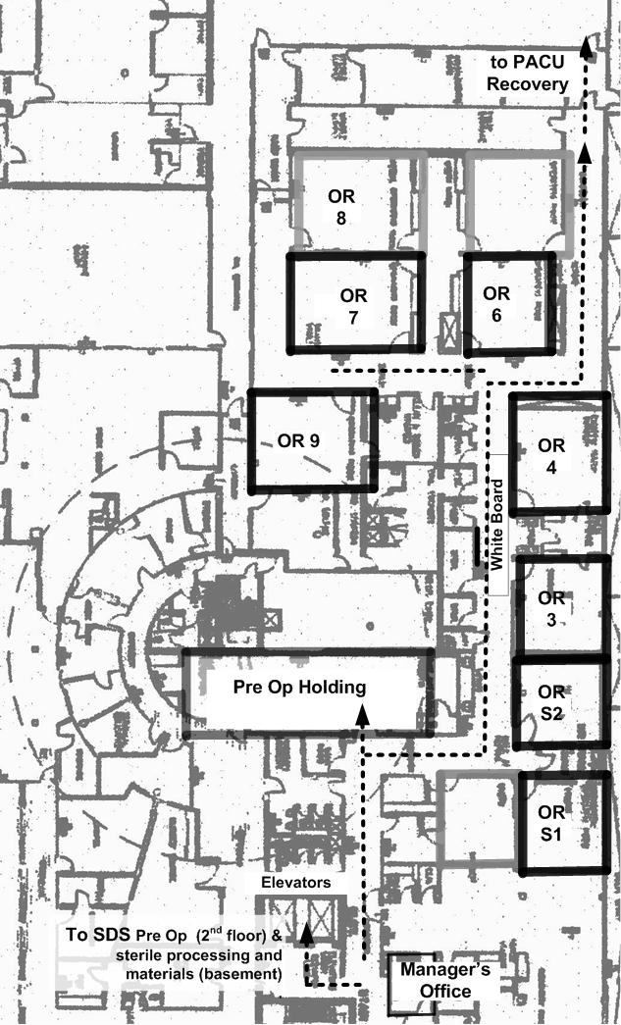
Figure IV-2. Physical layout of the 1st floor surgical area at VPH

The movement of supplies is largely from a basement department that moves via elevators.
Regarding the movement of patients, see Figure IV-2, the typical path is relatively straightforward. Four out of the 7 operating rooms are arranged in the main corridor of the OR where there is sterile storage area. The movement of supplies is also straightforward. Most supplies are moved from a basement central sterile processing area and are held in storage along the main corridor. The three remaining ORs are outside of that main corridor and although still connected to the general surgery area, they do not have immediate access to the sterile storage area, or whiteboard.

Outpatients start their day at registration on the first floor, which is located immediately to the left of the main entrance of the hospital. At the registration desk the patients log in and wait to for their name to be called and their final paperwork to be completed. Most of this occurs in the first part of the morning. Wait times were relatively short, we observed. Some emergency patients are brought there as well prior to surgery. Once registration is completed and a nurse or transporter is available, the patients are taken into the Pre-Op Same Day Surgery Center (SDS) on the second floor, where they begin certain pre-operative steps, including changing clothes and medication checks. Until no more than an hour prior to the scheduled surgery time, the patient should be brought to the holding area on the first floor; where interviews are conducted, surgery consent forms are completed, and the patient waits for surgery to commence. The patient goes directly from there to an OR.

When surgery is completed the patient is transported from the OR to recovery, or PACU (post anesthesia care unit). Recovery is located from a corridor past the OR’s. In PACU the patient is brought completely out of anesthesia, outpatients are then moved back upstairs to SDS from where they are discharged, while inpatients are moved back to their floor when they are deemed ready.

Along the main corridor in surgery, the area’s white board serves several purposes. It shows staff where they are assigned, as well as the status of upcoming cases, such as whether they are in the pre op area, late to arrive, or prepared and ready for the OR; as well as which rooms are opened and available for use.
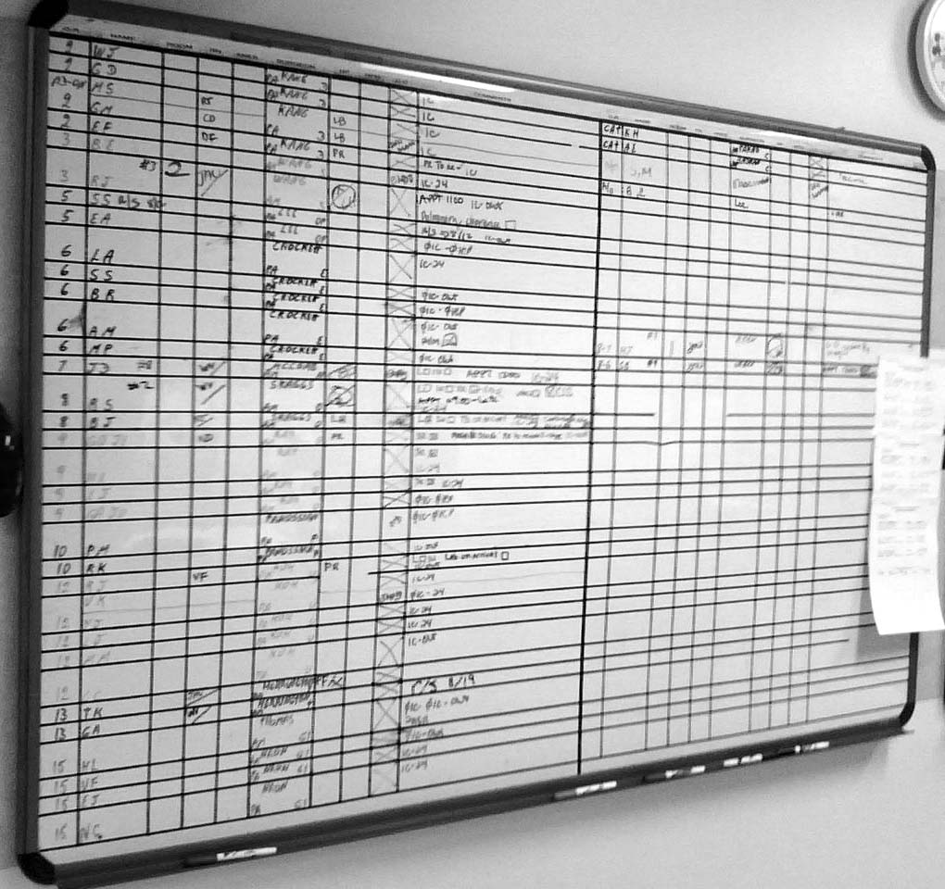
Figure IV-3. Typical surgery whiteboard

In the operating room the anesthesiologist and circulating nursing prepare the patient for intubation and monitor the patient throughout the procedure. When the surgeon arrives at the OR, they positioning and drape the patient and await the surgeon to begin the procedure. After closure and after the patient is wheeled out, a surgical tech, scrub nurse and perhaps the circulating nurse gathers materials for disposal or recycling. The room is cleaned by a housekeeping team, which consists of 2 people who generally work the entire shift.

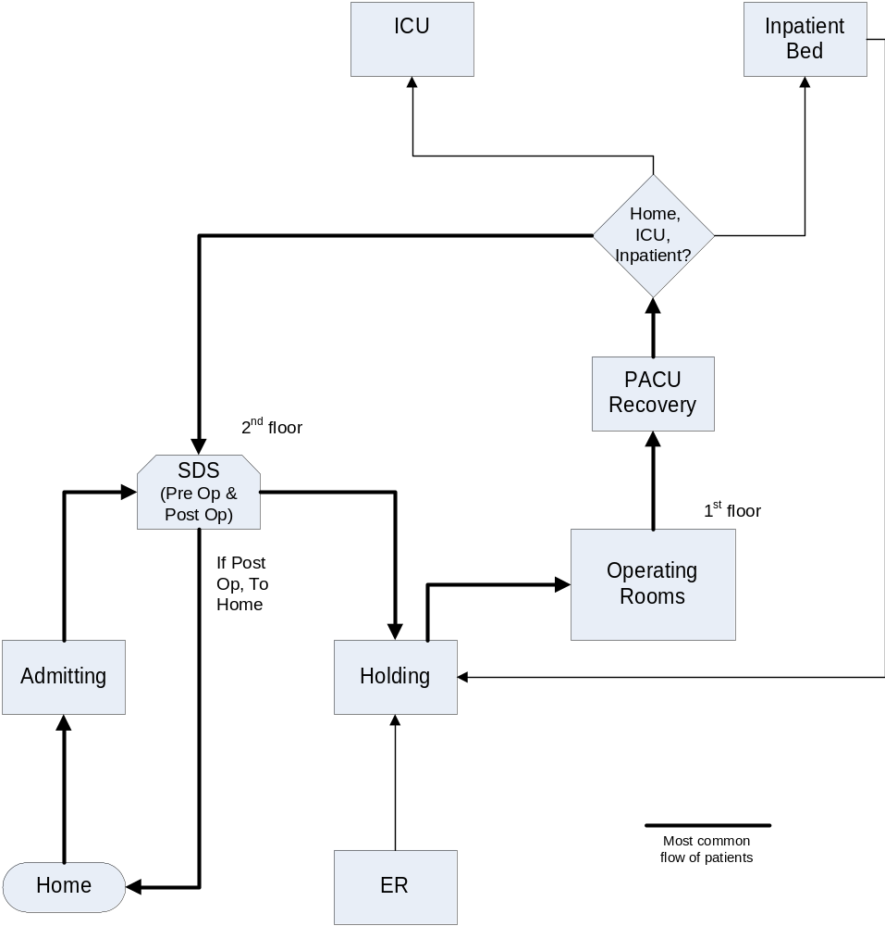
Figure IV-5 Patient Movement
At the time of our project, mostly late 2008 plus early 2009, the computer information system for surgery (ESI) recorded patient movement, such as the time patients moved into an operating room and when surgery began. However, its reports were quite limited and the hospital was unable to extract raw data that we could analyze. Before we began the surgery department began to record surgery patient flow data in a separate paper system so such analysis could be done. About the time we started, October 2008, a new nurse manager revised the paper system (called the OR Audit Tool) to record details of patient movement. This became our primary source for patient flow data but it had to be entered into a spreadsheet, which the hospital was doing. The ESI system maintained the daily schedule and various paper logs were used to record other information. Thus, we had to deal with multiple sources. The data entry from the OR audit Tool involved considerable delay, sometimes a month before the data was available in digital form. In early 2009 the hospital began to phase in a new system (MediTech) but the availability of raw data from this new system was too late for purposes.

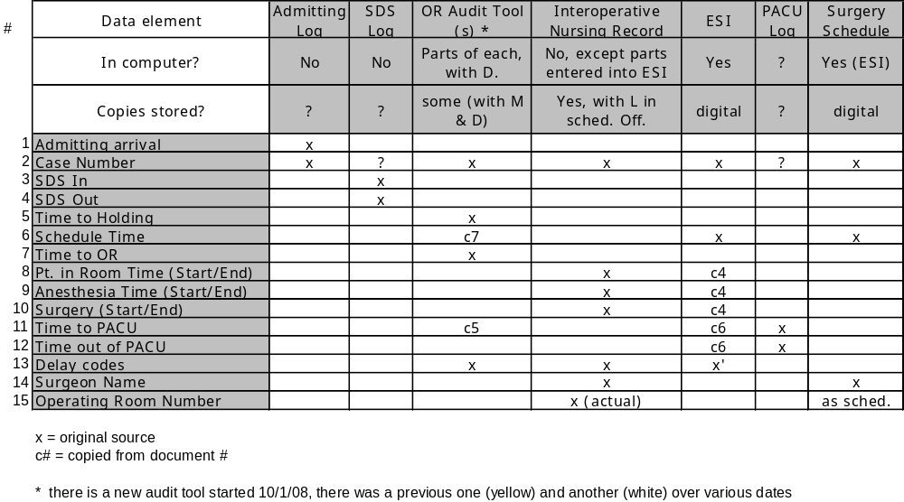
Figure IV-5 Available Patient Flow Data

Our source of information for this project was from observation of patient flow throughout multiple days as well as interviews. We spoke to people individually and in groups including nurses, surgeons, anesthesiologists, housekeeping and administrators. Our primary contacts included the managers of the surgery area, an administrative fellow reporting to the CEO and certain surgeons and anesthesiologists who took a particular interest in the project.

Findings

We observed patient flow in surgery over several weeks, interviewed staff, gathered statistical data and participated in group meetings and discussions. Through this data gathering and subsequent analysis we identified various bottlenecks and problems. All these issues we discussed with various hospital staff and management.

We determined the probable existence of the following patient flow related problems at VPH. These are listed in rough order of importance.

- Data. Information is needed for a patient flow dashboard and to understand & manage bottlenecks and performance. Existing systems, at the time we did our study, were challenging to interpret and difficult to utilize. Patient flow data was not available promptly. In some cases it took a month to get data on patient movement. A paper system for tracking patient flow, called the “OR audit tool”, provides only incomplete data. Patient movement data was not recorded at the time of occurrence and not all cases were recorded. As of February 2009 it was still in use although a new information system from MediTech had been implemented.
- Room utilization. Utilization should be better in terms of the percentage of the available time each operating room is occupied by a patient. Current utilization is about 60% vs. a common benchmark of 85% for hospitals similar to VPH.
- Communication in the OR is made difficult due to the physical layout, availability of information and whiteboard access. The Charge Nurse’s office located at a distance from ORs and whiteboard, which complicates and delays communications with the staff. Communications between admissions, SDS, Holding, ORs, PACU and clinical staff is a challenge and contributes to patient wait times. Many of the staff told us of this ongoing problem.
- Delays in room turnover due to patients being moved to Pre Op holding area late for surgery start from SDS. If the patient is late to the holding step there is not sufficient time for interviews or other tasks which means that a surgery will start later than necessary.
- Turn Over Time is longer than benchmark norms (but not much, often under 40 minutes vs. 30 minutes). An opportunity for improvement exists. The lack of regular and accurate reporting of turnover time makes the problem less likely to improve.
- Delays in case start both at start of day and during day. Late start result of surgeons, patients and prep paperwork.
- Equipment & supplies. Availability or conflict with other cases delays some cases, preferences (equipment requirements) were said to be out of date, layout problematic.
- Clocks in the OR area do not always show the same time
- The objective of keeping doctors happy at all costs may conflict with an efficient schedule and enforcing rules concerning start time, etc. Incentives differ between physicians, anesthesiologists, nurses and administration regarding prompt movement of patients and starting cases on time.
- Decision rules, guidelines for the scheduling of cases seemed unclear and not necessarily focused on maximizing utilization of the operating rooms. Scheduling procedure for cases other than normal daytime hours seems unclear.

Recommendations

The following recommendations have been discussed with the hospital.

- Data. The new MediTech system for surgery may solve problems in this area but meanwhile a spreadsheet can produce an effective report card using the MediTech system’s raw data as a source. Accurately recording patient movement times with the new system is key. We have seen other hospitals implement similar systems recently but they haven’t always produced desired results. The nursing staff must be aware of the need to promptly enter their own observations at the time they occur. With such input the hospital has a powerful resource to understand and manage patient flow. See suggested dashboard and calculations as shown in Figure IV- 7. This was done with an Excel spreadsheet but MediTech should be able to produce something similar.
- Utilization. Scheduling instructions and guidelines are needed to maximize utilization, perhaps double booking of cases or earlier patient movement and perhaps block assignment revisions. Report card is needed to track utilization and the results considered a measurement for scheduling success. If an IT solution not available, VPH could continue use of the OR audit tool or create its own utilization report card using the MediTech data as input. Utilization should be measured based on the usage of rooms in comparison to the available room time. Block time utilization is another interesting metric but is not the same as measuring the hospital’s overall use of the surgery resource.
- Communications. Walkie-talkie or other electronics can help. A number of staff and physicians expressed frustrations in being able to communicate with the surgery office. The surgery office also had challenges in contacting the medical staff. The Charge Nurse's office should be relocated so as to provide visibility of the ongoing flow. An office centrally located near whiteboard needed. The new IT system may support tracking graphics in the form of an electronic whiteboard. Perhaps providing an assistant for Charge Nurse would help communications. Supporting a strong Charge Nurse position is key to efficient patient flow in surgery. The current physical arrangement presents a burden.
- Moving patients to pre op holding. SDS-Holding communications & coordination needed and tied to OR status. SDS should monitor the schedule and work to move patients an hour before the surgery start time. Ideally, a “pull” system would cause the holding area to go get patients when they are needed or take the responsibility of getting the patients transported in. Its far easier for OR & Holding areas to be aware of the status of upcoming surgeries than for SDS to know when to “push” patients ahead.
- Turn Over Time Several schemes can be used to reduce turnover time and other metrics such as the number of first cases starting on time. Gathering and reporting delays, by type and my individual, can identify where problems exist. The new MediTech system can capture delays. The hospital should not be shy about recording such information and distributing it. The surgery information system accommodates it. A widely circulated dashboard can help. Making it clear that the OR nurses, such as the circulating nurse, have a responsibility to "pull" in the next case is helpful. The hospital can enlist nurse/doctor teams and focus groups to address the issue and review monthly results.
- Other recommendations. Synchronizing clocks could be dealt with by digital clocks or giving the responsibility to a particular individual. Cell phones provide time that is always accurate - there is no reason why the clocks on the wall can’t be accurate too. A storage location for case carts after surgery was needed but the department seemed to have recently defined a reasonable location.

A primary objective of the CHCF grant was to encourage management engineering in safety net hospitals in California. It would seem that VPH’s recent projects in optimizing transport staff, in analyzing patient falls and other projects would be evidence to the hospital that investment in productivity improvement is both possible and worthwhile.

Our recommendations were reviewed in several meetings with surgery management. We remain available for review of these findings and recommendations.

Data & Results

At the start of the project there was no overall regular patient flow report. We therefore developed a suggested report following a format that we have used in prior projects. The values are based on raw data provided us from the Charge Nurse’s so-called audit tool and the daily surgery schedules. The audit tool is a paper record of patient movement that includes times recorded by nurses in pre op holding and in the operating rooms. Often the nurses did not record various times, which were filled in later by the manager. With this raw data it was possible to compute various descriptive metrics about patient flow in surgery. For example, its possible to determine:
- Room turnover time (wheels in to wheels out)
- Room utilization
- Fraction of first cases starting on time
- Schedule accuracy, how actual times vary from scheduled times
- Distribution of these measures by time of day, day of week, room, service, surgeon, nurse or anesthesiologist

After computing these values, certain results indicated a problem. We were told, in advance, by hospital management that room turnover time was a priority because they felt is was a problem. The data bore that out. Often hospitals turn surgery rooms over in an average of ½ hour and often considerably less. At VPH it averaged about 40 minutes. An average of 20 minutes is not uncommon at other hospitals. This metric varies by type of surgery; some are more complex in terms of moving one patient out and moving another in.

The room turnover time, the time from when one patient wheels out until the next wheels in, is nearly a full hour. During the three months for which we received data, the overall average was higher in the afternoon than in the morning and was higher at the beginning and at the end of the week.

An important metric is room utilization. This represents the percent of the day during which the operating rooms are in use. We computed utilization as the time patients are in a room plus an allowance for room turnover – since a patient cannot be moved in the instant one patient leaves. From an economic standpoint, utilization is important since the OR is a very valuable resource. Hospital OR time has been calculated at $50 to $60 a minute.

Room utilization can be calculated two ways; as the usage of all rooms in the hospital and the usage of rooms staffed by nursing. Sometimes, a physical room exists but nursing staff has not been brought in to operate it. In either case we calculated utilization only during the regular weekday daytime shift.

Room utilization was an average of 59 percent and staffed room averaged a utilization of 63 percent. Typically hospitals target about 85% since 100% is considered unrealistic.

Schedule accuracy is another metric of interest. In order to make full usage of OR capacity, its necessary for the first case of the day to start on time as scheduled and for the remainder of the schedule to reflect a reasonably accurate plan. If not, the opportunity to complete the maximum number of cases is lost. This calculation is difficult; we did it for only one month, because the schedule history and the patient movement history are not stored in a common system. Past schedules were available only in paper form. However, it is feasible to set up a common digital file or do such calculations only periodically as a sample. See Figure IV-7.

We found first case starts to be relatively good. For the three months we had data, about 85% of the first cases started on time, which is above the national benchmark of 75%. We did also notice from the data, though limited, that about one third of all cases where more than 15 minutes late when compared to their scheduled start time.

We have found, and many hospitals have also concluded, that a regular patient flow “dashboard” or report card is helpful to improving and maintaining good patient flow. The report needs to be clear and easy to interpret. It should measure important variables, such as we have described above. See Figure IV- 7 below. Most of the commercial surgery information systems provide such a dashboard with room utilization, turnover time and scheduling metrics in terms of their details, trends and comparison to benchmarks. VPH should do this. While patient flow data is currently cumbersome to utilize, the raw data is there and the new MediTech system has the capabilities. A computer system used by nurses in the operating room records the important patient flow times and is the basis for such a report.

We also believe such a report should receive wide circulation among the staff. Employees want to be proud and satisfied with their work but need to know how they are doing. Even performance data on individual physicians, while it may “stir things up”, provides a feedback to the doctors. It focuses attention on throughput and provides motivation. Some hospitals we have worked with have reported individual physician performance but with names hidden with a code whereby the physician knows their own ID code but not the code for others.
Figure IV-7 Surgery Dashboard

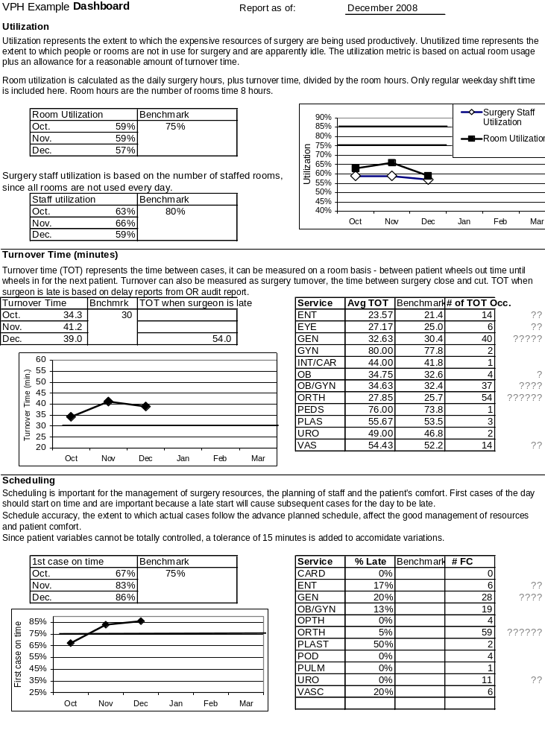
Figure IV-7 Surgery Dashboard (continued)

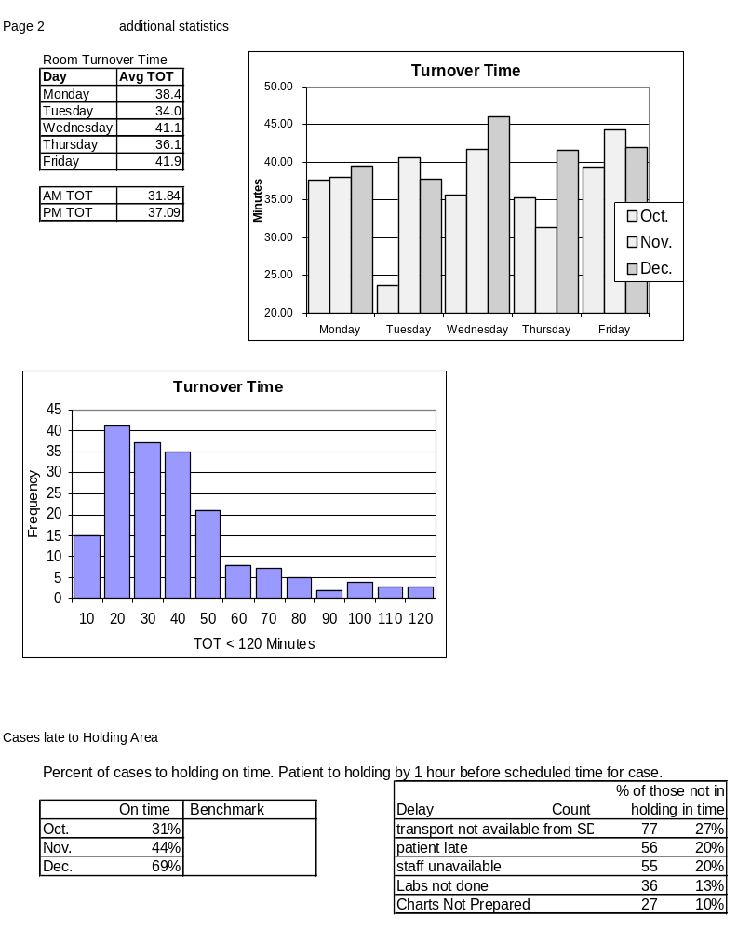

Figure IV-7 Surgery Dashboard (continued)

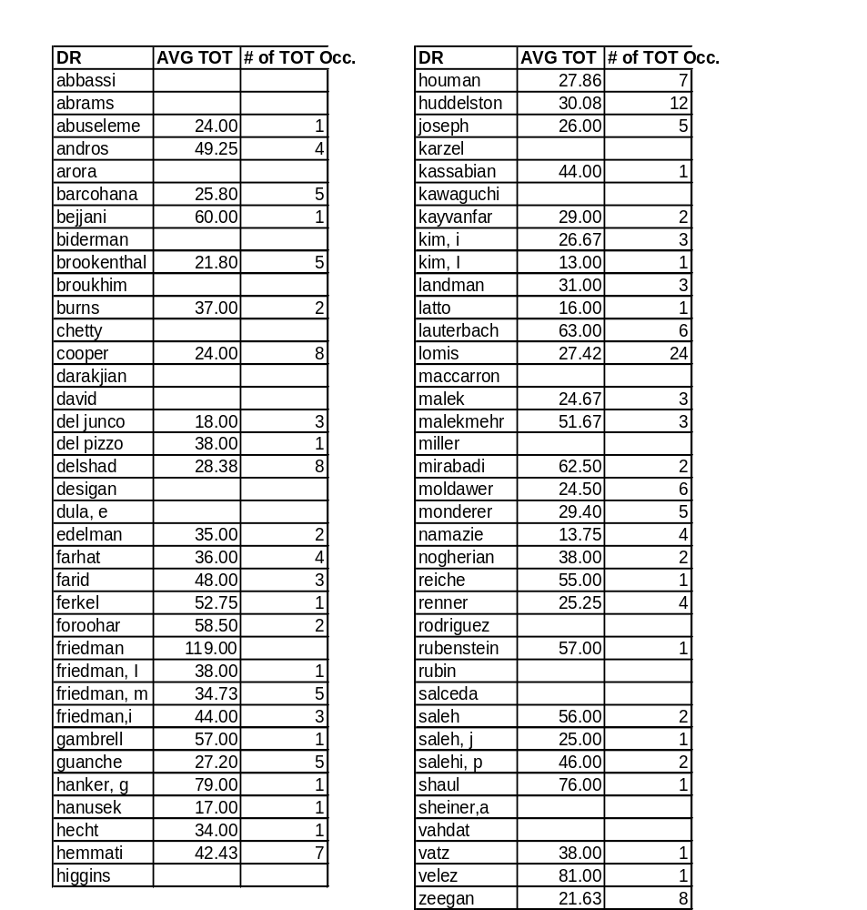

Appendix

Proposal Evaluation Matrix

A matrix of a weighted average of scores for various attributes was used to evaluate the proposals received from hospitals. The total for each hospital was the sum of each hospital’s score on an attribute times the weight for that attribute. The top 3 total scores were used to select the hospitals.

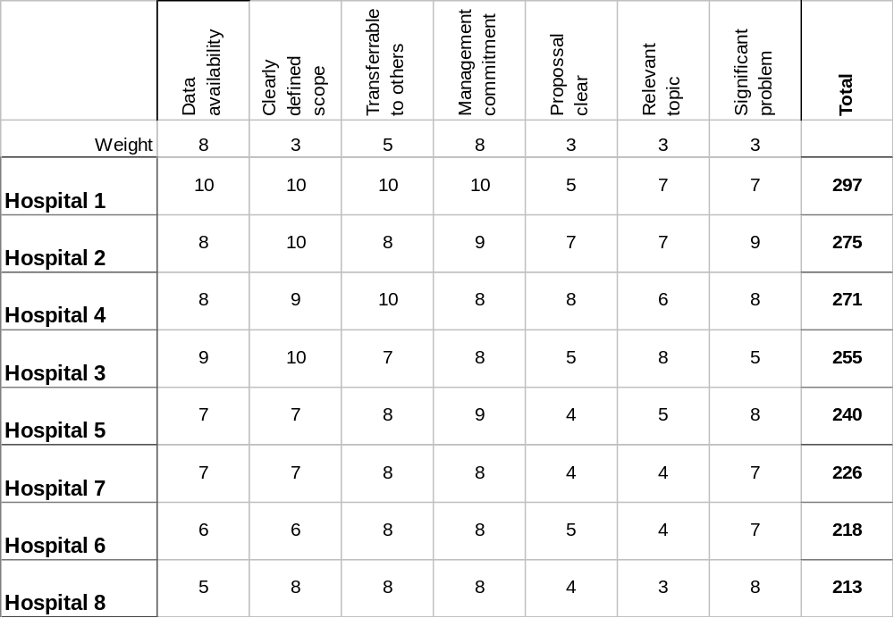

Project Startup Checklist

The following was used at the start of each project.

Checklist for ___________________ completed on_________

Discuss and complete the following with hospital at the start. Enter notes.

- Scope, it is ______________________
- Agreement letter signed ___________

Logistics
- Primary contact person is ________________
- Schedule Kick off meeting with as many people as possible ___________
- CEO meet ______________
- Parking _______________________________
- HIPPA requirements, TB requirements __________________
- Access badges __________________________
- Office space, computer access _____________________________
- Will do follow up memo __________________________

Content
- Who are the key stakeholders in this? _________________
- Metrics, are we clear? What is available now? ___________________

- We do ongoing status reports & meetings __________________
- Explain early tasks; process maps, data sources
- Any phonebook or directory available?
- Any prior studies, consultants, prior work _____________________
- What documentation is available on processes, forms control?
- Who is IT contact, source of queries? _________________
- What are their regular meetings, committees _________________

Hospital Data

The hospitals in this project all maintained detailed digital records regarding patient flow. Timing of patient movement was recorded by nurses and by anesthesiologists, often in separate systems. An example of the raw data used as an input for the analysis this report is shown below. The hospitals also recorded patient movement in admissions, pre op and recovery, although often in separate computer systems or more limited paper records.

Example VPH data:

